HEXHAM & NEWCASTLE

St Michael’s Catholic Primary School

Within Bishop Bewick Catholic Education Trust

Clumber Street North, Elswick, Newcastle upon Tyne, NE4 7RE

Tel. 0191 2739383
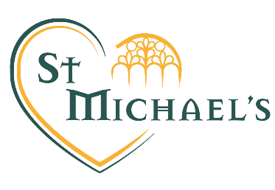

SUPPORT ASSISTANT- LEVEL 2

Required November 2024

Grade BB03 £23,114 - £23,500 per annum pro rata, Actual £17,648 - £17,942 per annum
32.9 hours per week, term time plus 5 training days

*This post attracts a Living Wage supplement. In addition to the hourly rate, this post will receive the Living Wage supplement to bring the hourly rate up to a minimum of £12.00 an hour.*

Fixed term for 1 year with the possibility of becoming permanent

We are looking to appoint a hardworking and inspirational Support Assistant to work with our enthusiastic and hardworking pupils and staff.

We warmly welcome applications from someone who:

- SEN experience
- can support and promote our distinctive Catholic ethos and values
- demonstrates excellent classroom practice
- has high expectations of children’s attainment, progress and behaviour
- believes in the potential of all children to succeed
- is cheerful and enthusiastic and works as a part of a team to achieve very high standards

We can offer:
- a very positive and caring ethos
- supportive, enthusiastic and dedicated colleagues, governors and parents.
- very well behaved, happy children who enjoy school.

Applications must be made on CES forms which are available from the school's website and submitted by the closing date for the attention of the Executive Headteacher, Mrs C Chapman at the above address.

St Michael’s Catholic Primary school is committed to safeguarding and promoting the welfare of children, young people and vulnerable adults and expects all staff and volunteers to share this commitment. Successful applicants will be required to obtain an Enhanced Certificate of Disclosure from the Disclosure and Barring Service and a range of recruitment checks.

Closing Date: 12 noon on 04/11/2024
Shortlisting: 04/11/2024
Observations & Interviews: W/C 11/11/2024

